PROJECT AUDIT REPORT

**CP 5047: ICT2**

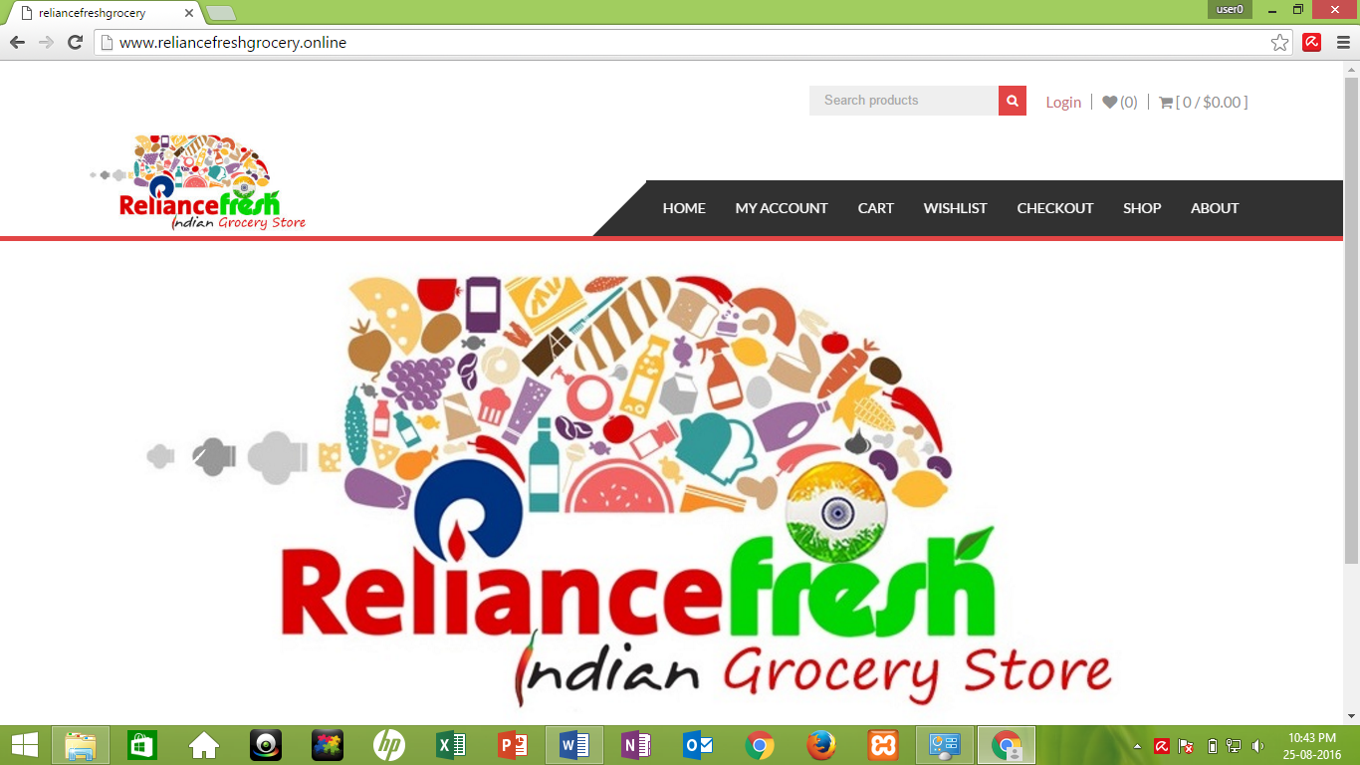

<www.reliancefreshgrocery.online>

**Submitted to: Submitted by:**

**Laura Antochi Anay Gharat**

**Gagandeep Singh**

Table of Contents

PROJECT ROLES 3

User Stories for Alpha, beta and Final Release 4

Domain Transfer to www.reliancefreshgrocery.online 5

Google Analytics 5

SEO tags 5

PayPal 5

Social media Integration 5

Bug fixes 5

TESTING WITH TELLURIUM 6

Home page 6

Registration page 7

Cart 9

Contact us 11

Pay pal 11

Differentiation between Alpha, Beta and Final Release 12

Velocity and Burndown charts 14

Project maintenance ICT infrastructure 17

Client acceptance, testing and conclusion 17

**PROJECT ROLES**

Anay Gharat

* User interface design
* Meeting arrangement with client
* Gather requirements from client
* Selecting suitable theme & templates for website
* Pay Pal
* SEO tags
* Sandbox testing
* Meta slider

Gagandeep Singh

* Project documentation
* User interface design
* Database making and connectivity
* Site layout
* Google Analytics
* Social Media Integration
* Site testing using Tellurium

**User stories of Alpha, beta and Final Release**

|  |  |  |  |  |  |  |
| --- | --- | --- | --- | --- | --- | --- |
|  | **Week** | **User Story** | **Description** | **Priority** | **Test by Client** | **Status** |
| Alpha ICT2 | 1 | Homepage | Homepage with new theme and upgraded logo. Product's pictures have been added into slider. | 10 | Yes | Done |
| 2 | Wish list | User can add their favourite items into wish list for future purchase. | 10 | Yes | Done |
| 3 | Shop | Few products have been added into shop page from where user can put items into shopping cart. | 5 | Yes | Done |
| Beta ICT2 | 4 | My Account | User can log into his account if he has registered with website. | 10 | Yes | Done |
| 5 | About | All the information about the store has been updated into this page. | 10 | Yes | Done |
| 6 | Shopping Cart | Content management, quantity and price of product can be seen in this section. | 5 | Yes | Done |
| Final ICT2 | 7 | Checkout & Payment | This section will display the billing details and payment method which will be PayPal. | 10 | Yes | Done |
| 7 | SEO | Using keyword Reliance Fresh for homepage. | 5 | Yes | Done |
| 8 | Google Analytics | for tracking the user who visit the website with location. | 5 | Yes | Done |
| 9 | Social Media Integration | Website is linked to Facebook account. | 5 | Yes | Done |
| 10 | Bug Fixes | Few changes have been done as per client's advice. | 10 | Yes | Done |